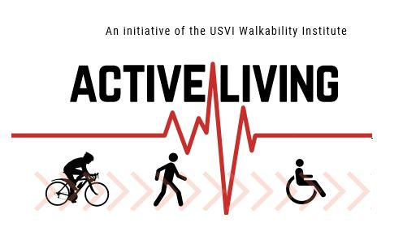

2018 USVI Walkability Institute Agenda

February 2, 2018 Link
March 9, 2018 Link
March 23, 2018 Link
April 13, 2018 Link
May 4, 2018 Link
May 21, 2018 Link
June 29, 2018 Link
August 1, 2018 Link CANCELLED
August 10, 2018 Link
September 13, 2018 Link
November 2, 2018 Link
December 7, 2018 Link

