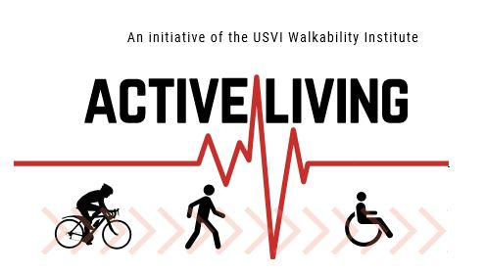

2019 Agendas

January 18, 2019 Link
February 21, 2019 Link
March 25, 2019 Link
April 10, 2019 Link
May 31, 2019 Link
June 28, 2019 Link
July 31, 2019 Link
August 23, 2019 Link
September 30, 2019 Link
October 25, 2019 Link
December 6, 2019 Link

